**Verification Plan for SRAS(JAVADB1) Application**

**MySQL Minor Version Upgrade from 8.0.27 to 8.0.28**

**MASG-3SRASJAVADB1**

* Check - application is up & running.

As soon as we received the mail from the respective team, asking us to validate the application after the patching activity is over, go to the deploymanager link for this application.

http://3srasjavaapp1.mas.net:8080/Deploymanager/html

Enter the username and password

**Username: tomcatusr**

**Password:** TqKwkH2d

As we have 2 apps to validate here – CLRS and SMSDashboard

Now first click on /clrs. Login page will be visible for this app.

Now you can login and move forward with the verification of application.

Simultaneously capture the artifacts for proof.

* Artifacts:

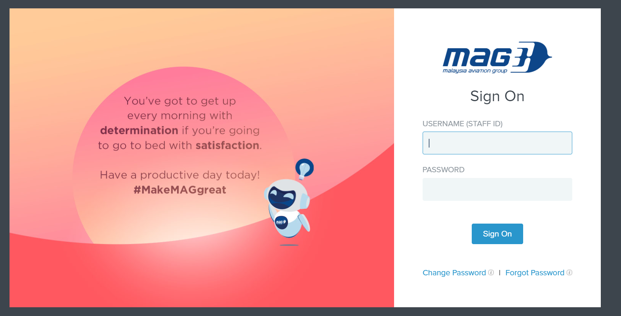

* Application Login is working fine.

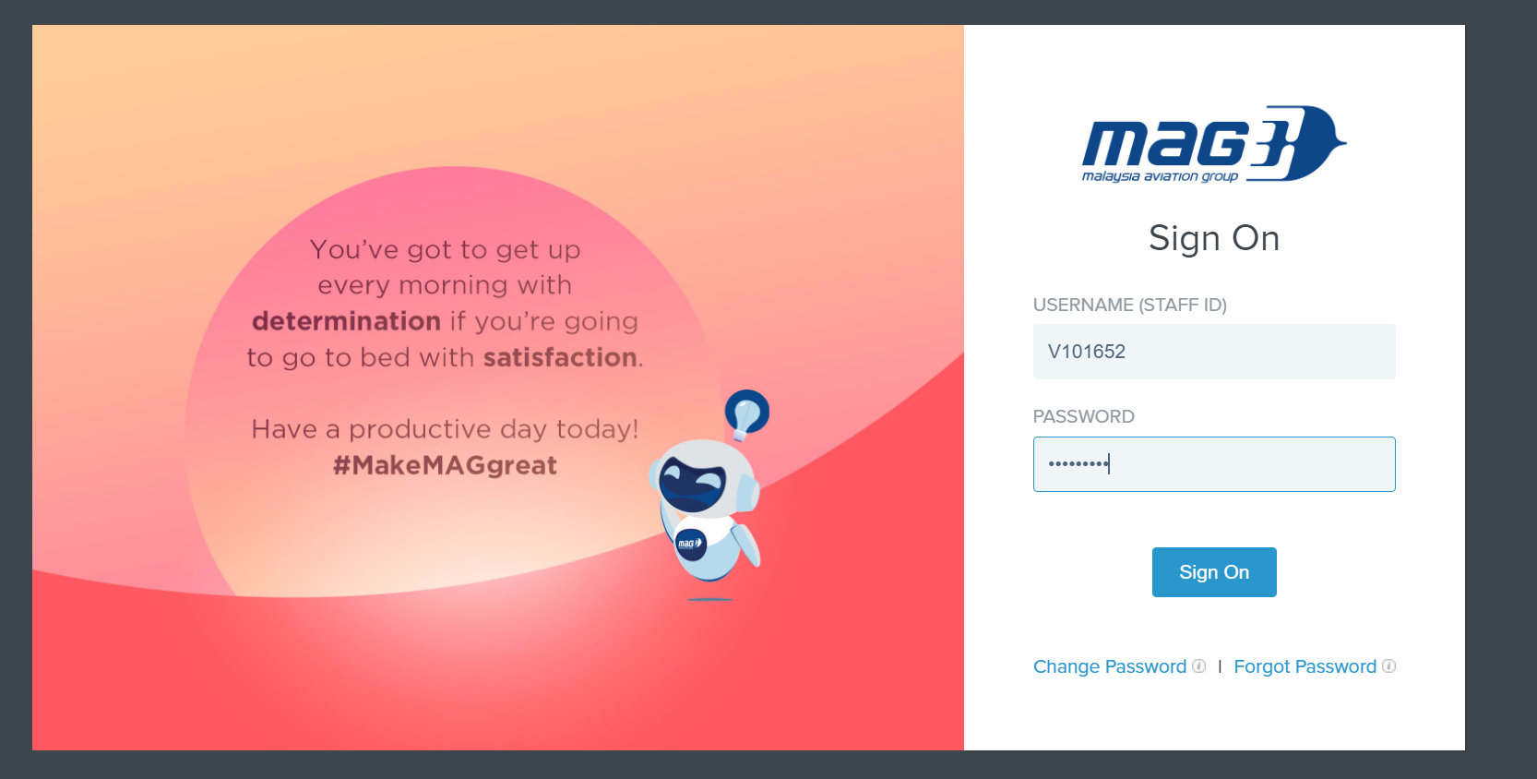

* Released functionality./Basic functionality.
* Home page - after login is successful

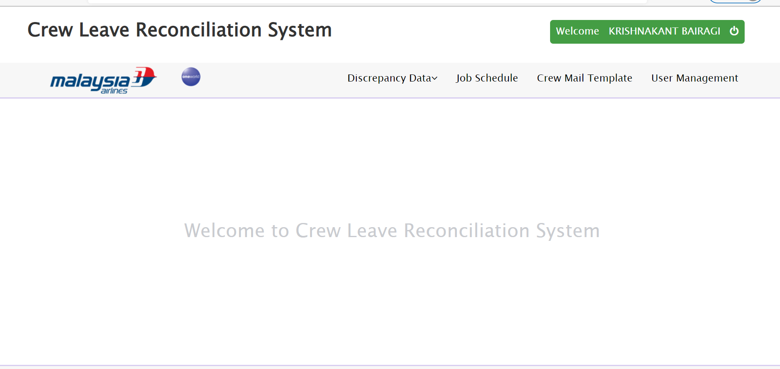

* Job Schedule

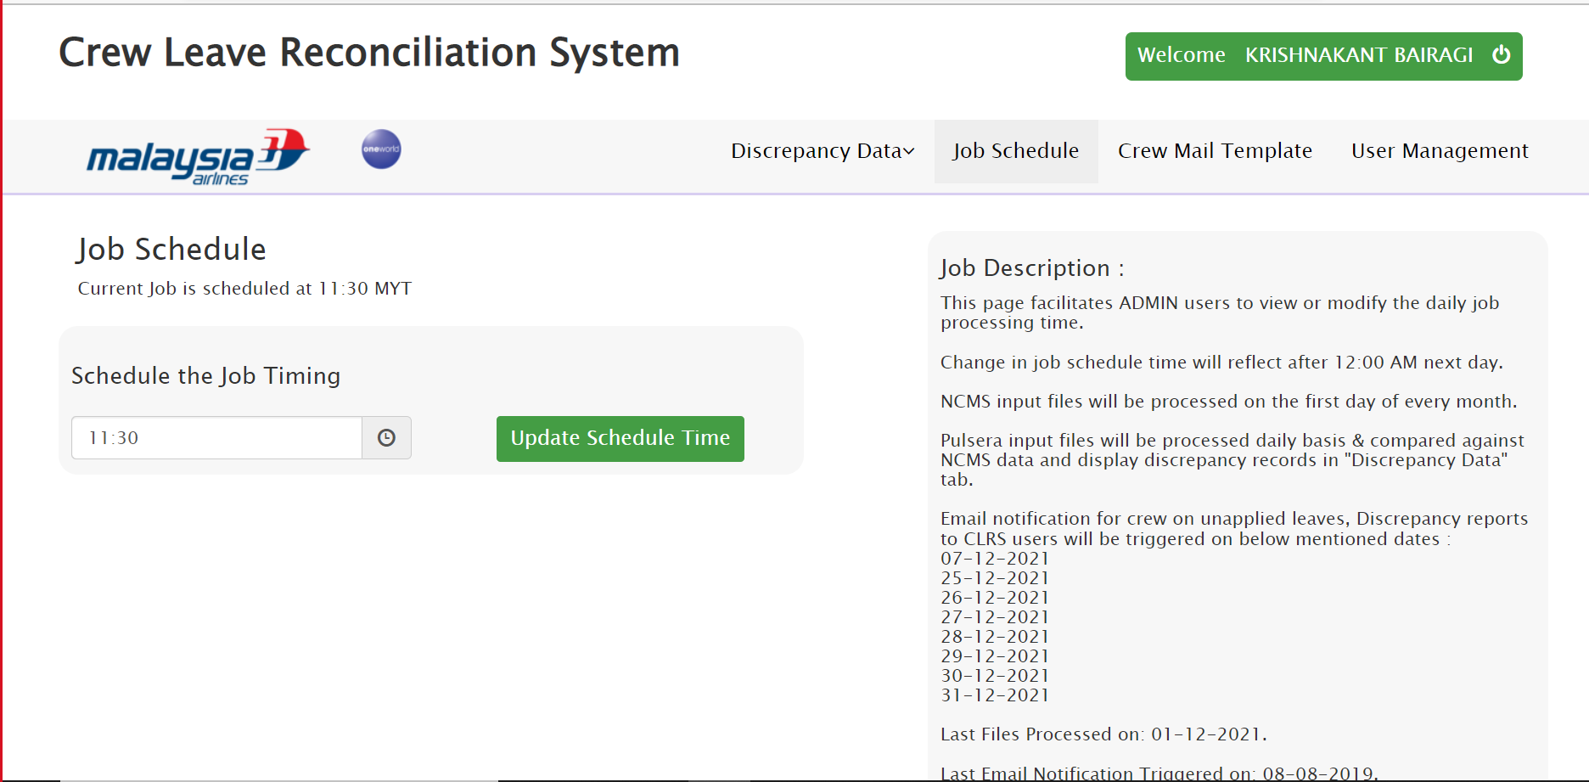

* User Management section

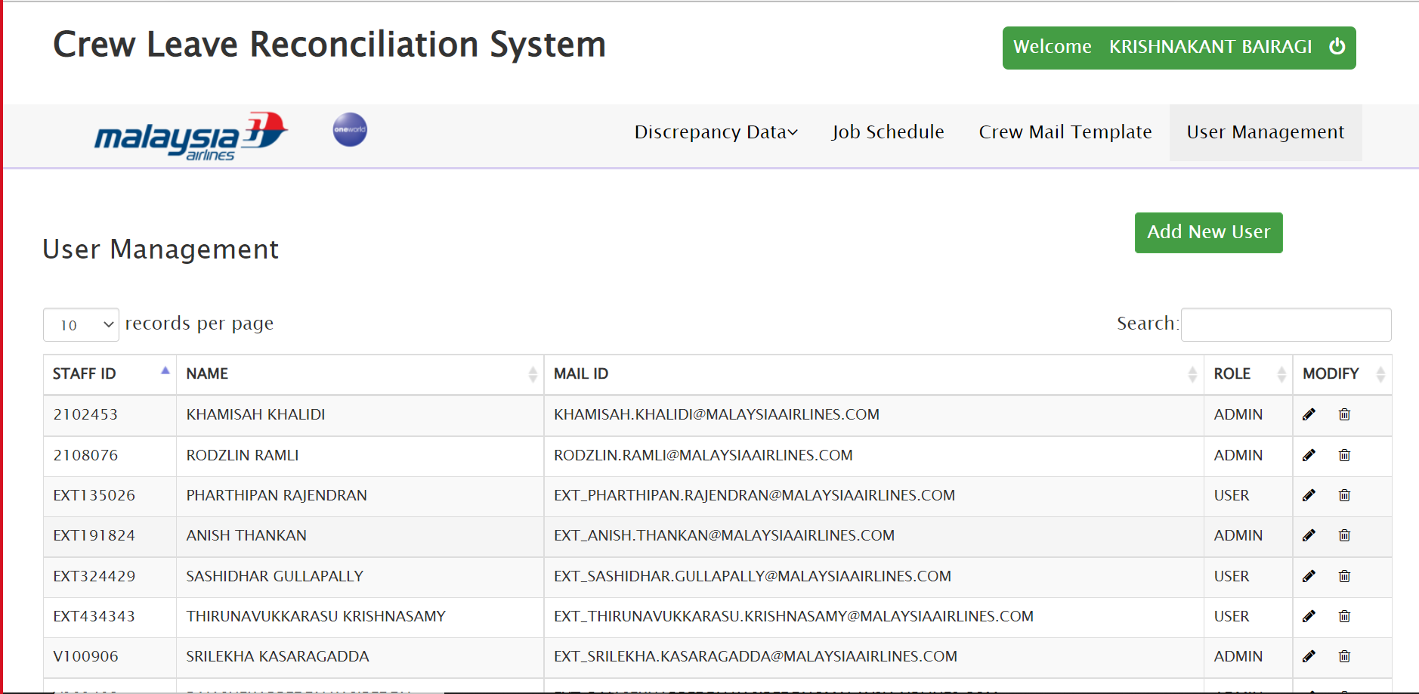

* Verify the log - Check for any unexpected error.

As you will be having the server access for this application – Check the logs with this

**ip- 10.221.12.29**

**logpath -** /tomcat/apache-tomcat-9.0.0.M11/logs/clrs.log

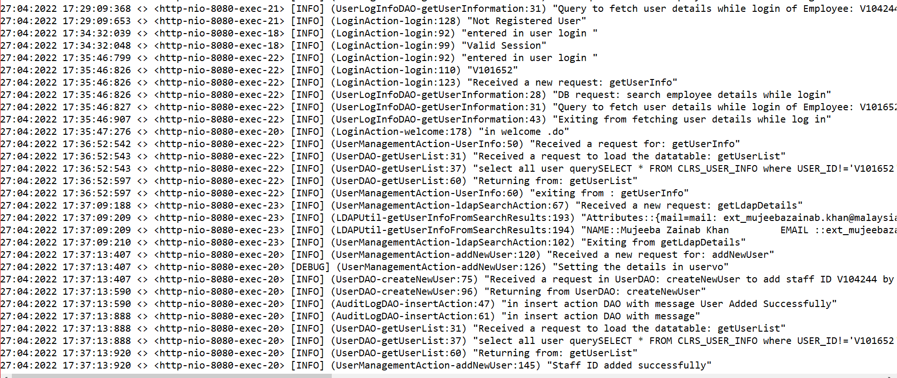

As we have validated the application and its working fine, now revert back with the same acknowledgement to that particular mail.

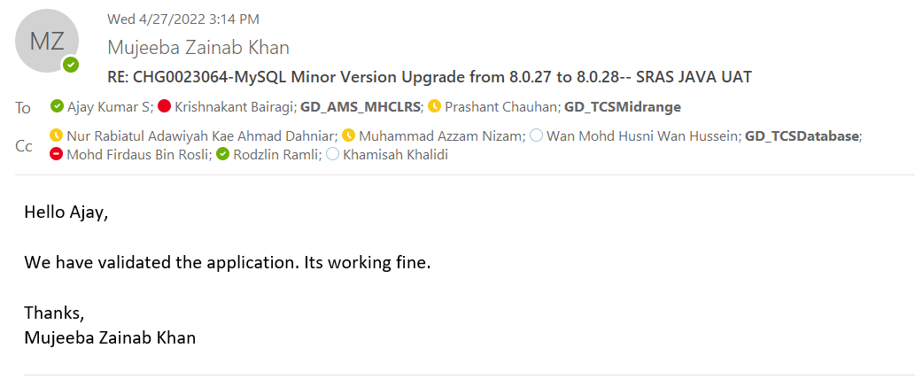

Now first click on /SMSDashboard. Login page will be visible for this app.